**http://whatculture.com/gaming/10-essential-point-click-adventures-must-play?page=11**

**10. Blade Runner**



**9. Myst**

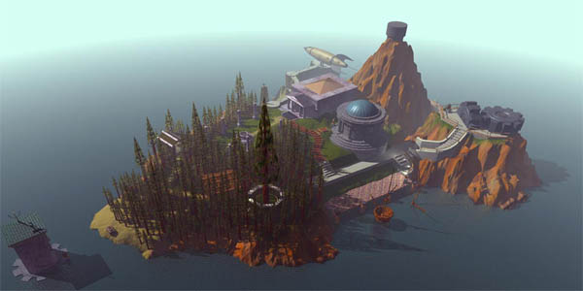

**8. Maniac Mansion**

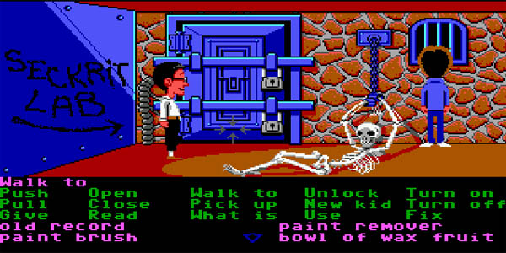

**7. Syberia**

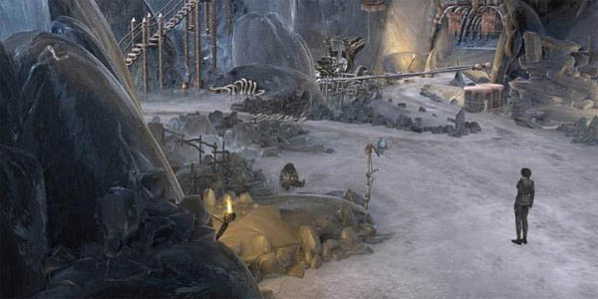

**6. Secret Of Monkey Island**

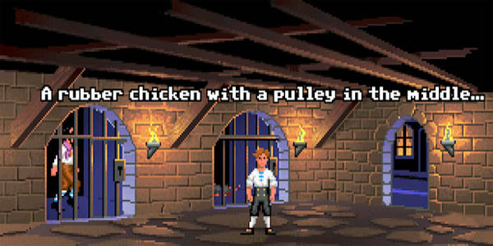

**5. Grim Fandango**

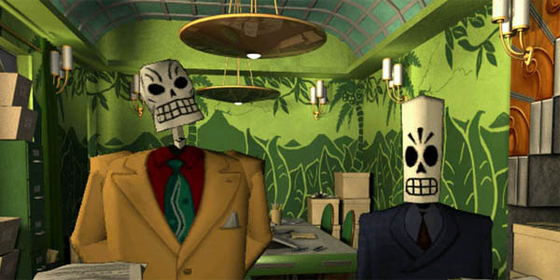

**4. Beneath A Steel Sky**



**3. The Last Express**

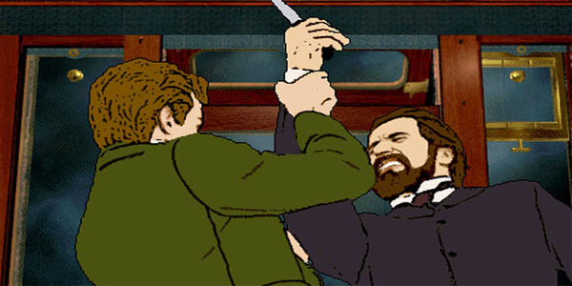

**2. Discworld**

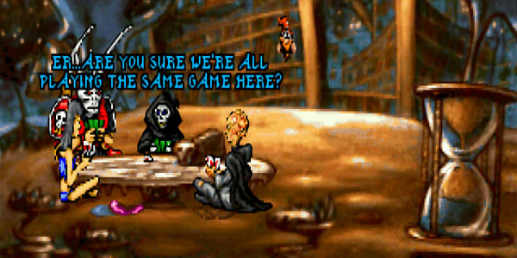

**1. Broken Sword**

